**User Entity**

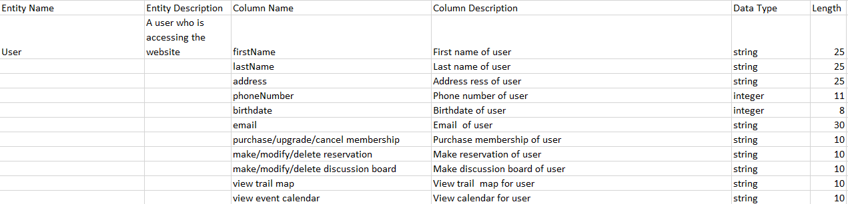

**Wilderness Louisville (Admin) Entity**

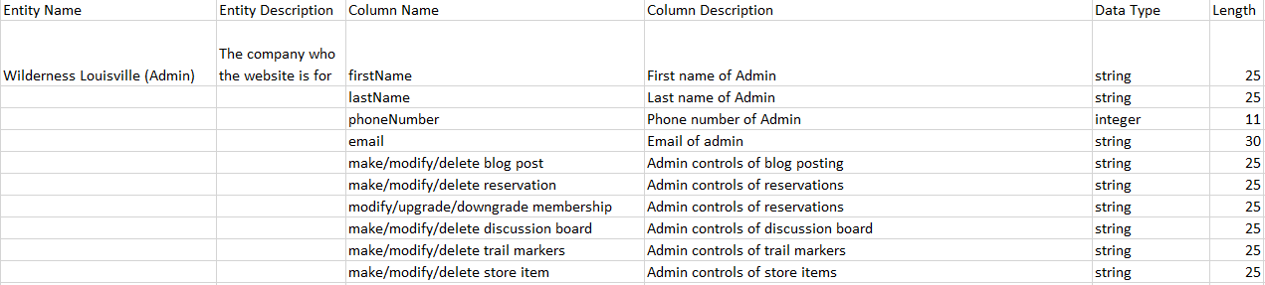

**Reservation Entity**

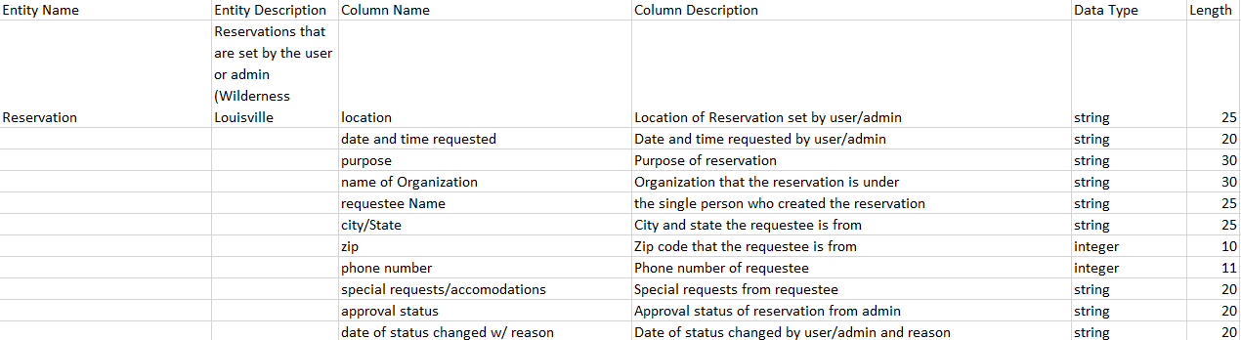

**Discussion Board Entity**

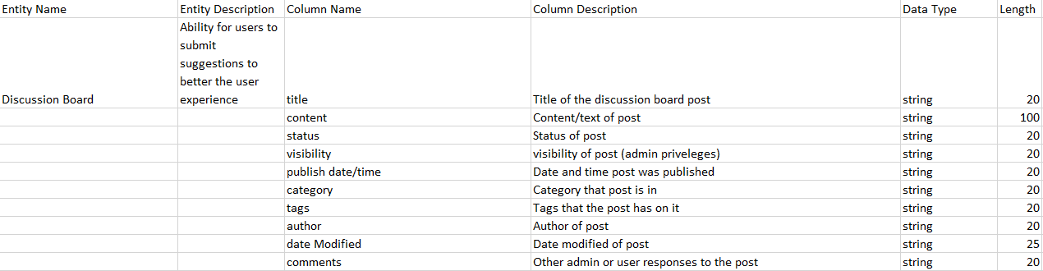

**Blog Entity**

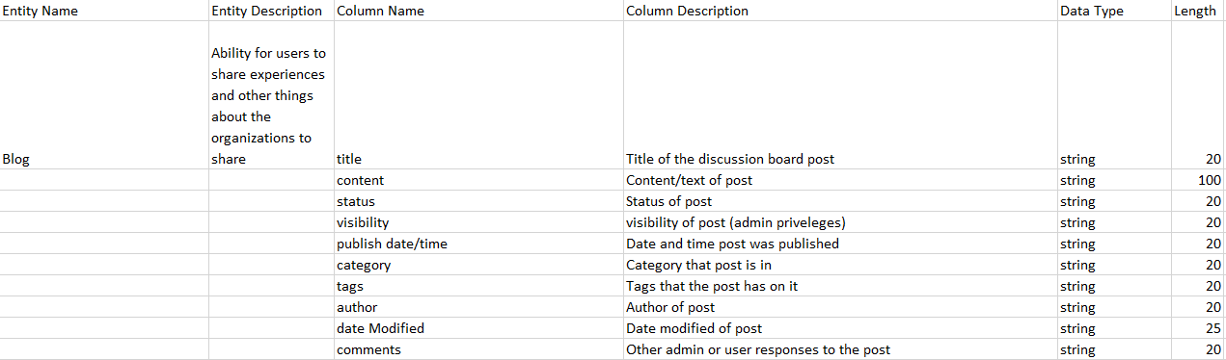

**Event Calendar Entity**

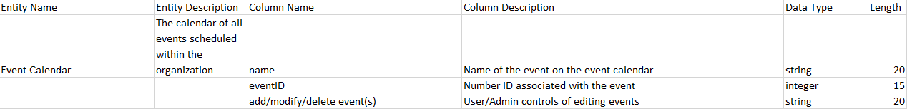

**Online Store Entity**

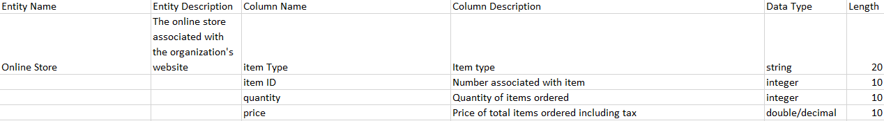

**Store Item Entity**

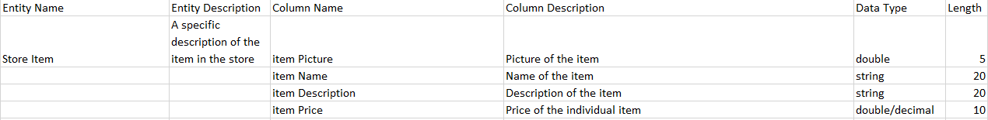

**Sold Item Entity**

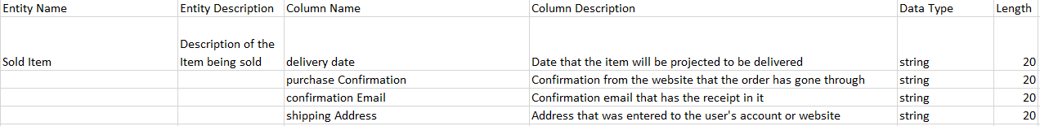

**Membership Request Entity**

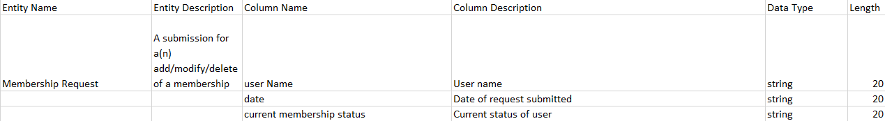

**Trail Map Entity**

